Sample post # 1
Text | Find @SCENT_EU on social media!  Website: https://scent-project.eu/  Twitter: https://twitter.com/SCENT_EU  Facebook: https://www.facebook.com/ScentEU  Instagram: https://www.instagram.com/scent_eu/  YouTube: https://www.youtube.com/channel/UCIsYktdt5p8RJUwCMA_ESFg  LinkedIn: https://www.linkedin.com/groups/13575337
Image | 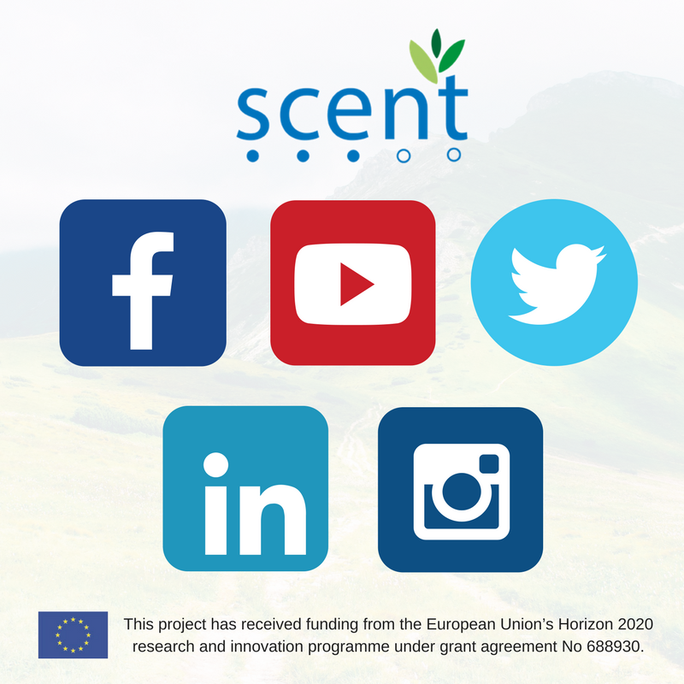

Sample post # 2
Text | Get the @SCENT_EU newsletter straight to your inbox by subscribing to it here: https://scent-project.eu/newsletter-signup. It gives you regular updates on project progress, highlights, relevant events and ways to get involved. The newsletter is published once per season.
Image | 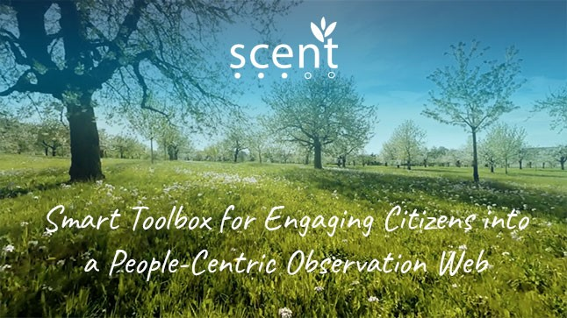

Sample post # 3
Text | Meet the @SCENT_EU project partners – follow our Spotlight series of interviews featuring one partner at a time: https://scent-project.eu/category/news/project-news
Image | 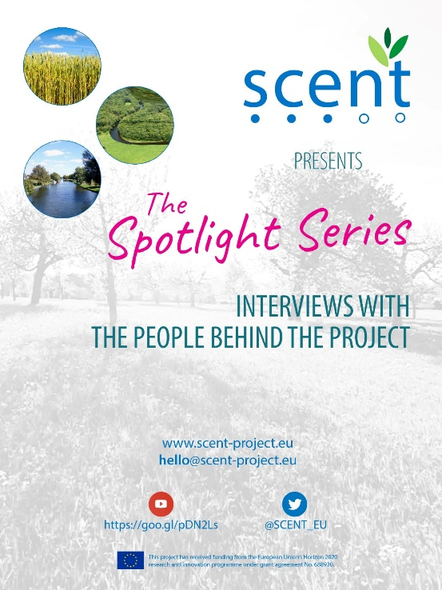

Sample post # 4
Text | I’m joining the @SCENT_EU movement! Join me and discover how #crowdsourced data can help to improve #flood maps https://scent-project.eu/ #citizenscience #H2020 #InvestEUresearch
Image | 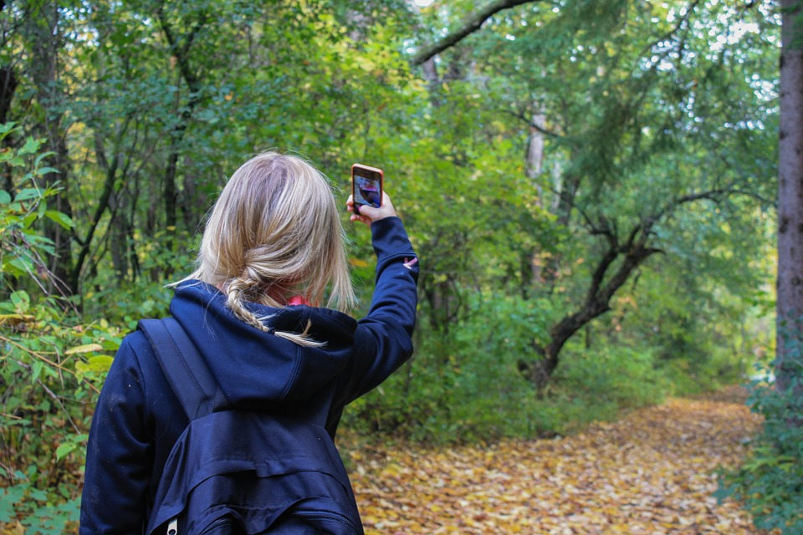

Sample post # 5
Text | Want to join our @SCENT_EU activities? Our campaigns in Kifisos start in September. Sign up for more info: https://scent-project.eu/newsletter-signup #H2020 #InvestEUresearch
Image | 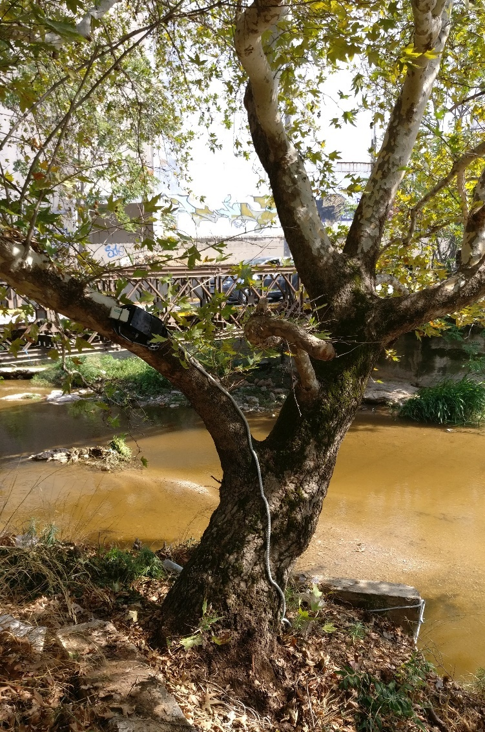

Sample post # 6
Text | Want to join our @SCENT_EU activities? Our campaigns in the Danube Delta start in August. Sign up for more info: https://scent-project.eu/newsletter-signup #H2020 #InvestEUresearch
Image | 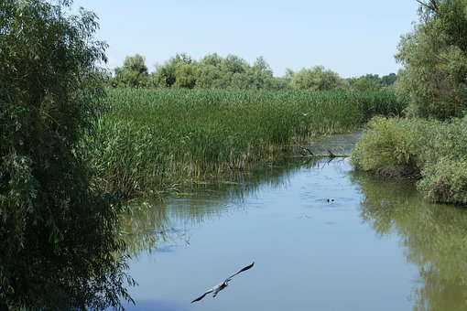

Sample post # 7
Text | Did you know that your smartphone can be used as a tool for monitoring land-cover and land-use around you? Check out the @SCENT_EU website to find out more: https://scent-project.eu/ #H2020 #InvestEUresearch
Image | 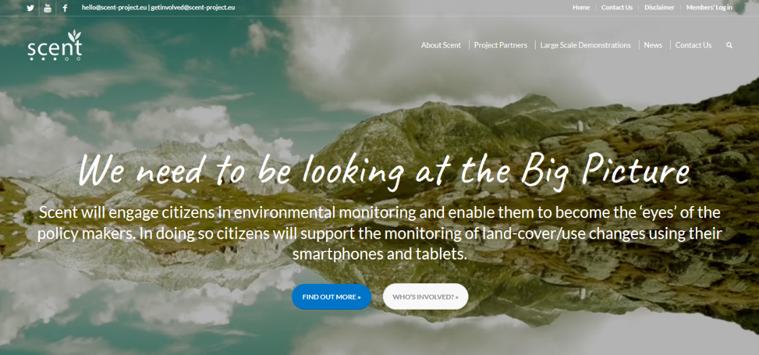

Sample post # 8
Text | Did you know that you can influence flood monitoring and management simply by playing a game on your phone? Meet some of the cute little @SCENT_EU Explore characters: https://scent-project.eu/ #H2020 #InvestEUresearch
Image

